**Sonic Pad**

**Firmware Burning Tutorial**

**（Ubuntu）**

|  |  |
| --- | --- |
| Version | V1.1 |
| Date | 2023/1/10 |
| version record | V1.0 initial version  V1.1 Chapter 4 Add Notes Before Burning |
| editor |  |

**Shenzhen Creality 3D Technology Co., Ltd**

**Catalog:**

1. Tools： 3

2. Enter the burning mode 3

3. Driver Installation 3

4. Sonic pad firmware burning 4

5. Precautions 6

## Tools：

1. LiveSuitV306_For_Linux64.zip for 64-bit systems, and LiveSuitV306_For_Linux32.zip

for 32-bit systems

1. （burn firmware）t800-sonic_lcd_uart0_1.0.6.40.112.img
2. Male to male USB cable( TYPE-A TO TYPE-A)

## Enter the burning mode

1. When the Sonic pad is turned off, insert the USB cable into the CAM port
2. Press and hold the FEL button on the right with a paper clip
3. Press the Power button to power on the Sonic pad, then the Sonic pad will enter the burning mode

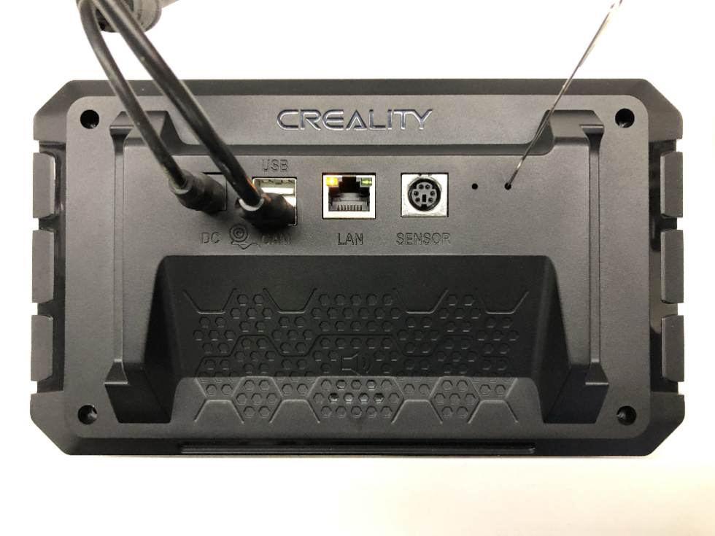

FEL

Power

## Driver Installation

It is recommended to use Ubuntu 18 or Ubuntu 20. Other versions of Ubuntu may encounter installation problems, please solve the problem by yourself.

Installation Guide:

1. The binary executable file is LiveSuit.run. If the file does not have execution permission, please use the command: chmod +x LiveSuit.run in the terminal to add executable permission to the file.
2. Open the terminal, enter the LiveSuit_For_Linux64 directory, and enter ''./LiveSuit.run' ' to run the installation program. (If the dkms module is missing, please use the command: ''sudo apt-get install dkms'' to install dkms)
3. The program is installed in the Bin directory of the current user's Home directory. After the program is installed, enter the program directory and enter the command ''./LiveSuit'' to run LiveSuit. The Ubuntu release version can add udev rules as follows to read and write hardware devices without root privileges
4. Open a terminal and enter ''sudo vim /etc/udev/rules.d/10-local.rules''
5. Enter the content of the following udev rules, and be sure to replace test with the user group where the current user belongs.

SUBSYSTEM!="usb_device", ACTION!="add", GOTO="objdev_rules_end"

#USBasp

ATTRS{idVendor}=="1f3a", ATTRS{idProduct}=="efe8", GROUP="test",

MODE="0666"

LABEL="objdev_rules_end"

1. Save and restart the machine or restart the udev service to run LiveSuit.sh as a normal user. The command to restart the udev service is: sudo service udev restart.
2. During the process of flashing the firmware, please do not close the program or disconnect the device to avoid hardware damage.

## Sonic pad firmware burning

Notes before burning the firmware: Run the LiveSuit software first, connect the Sonic pad to the computer with a male-to-male USB cable, and then let the Sonic pad enter the burning mode. The specific steps are as follows:

1. Enter the LiveSuit directory and execute the ./LiveSuit.sh command to start the LiveSuit program and select the firmware to be burned

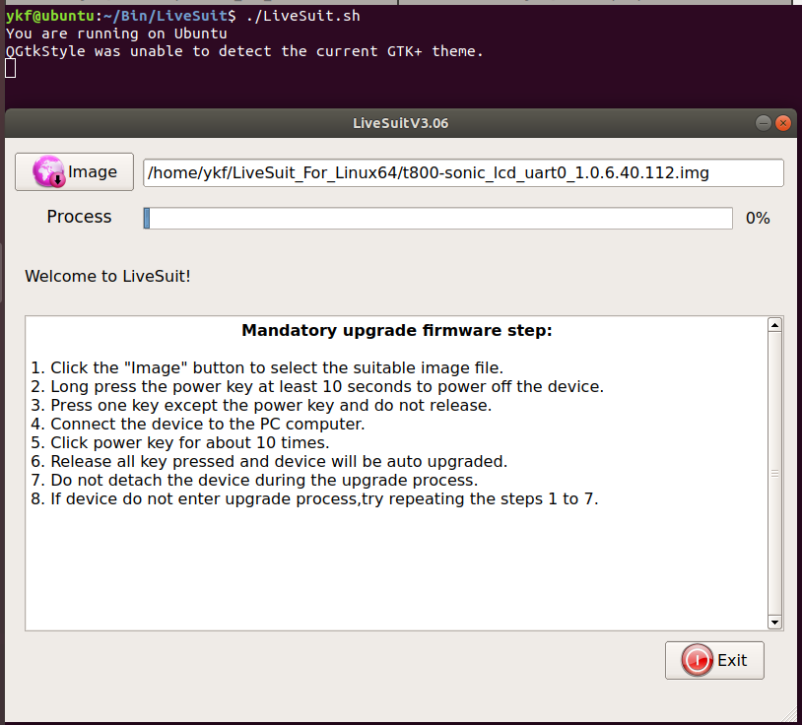

1. Connect the Sonic pad to the PC and enter the burning mode (please refer to Chapter 2). The following page appears, click the "Yes" button

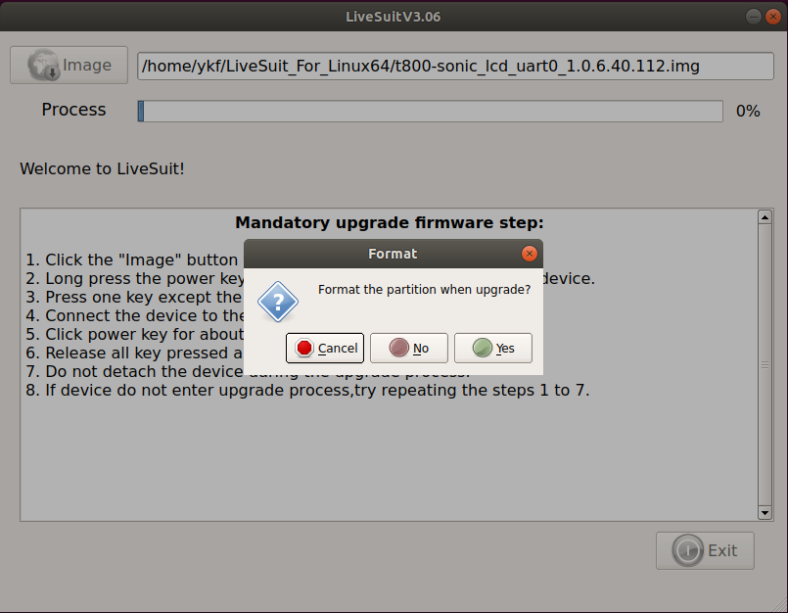

burning...

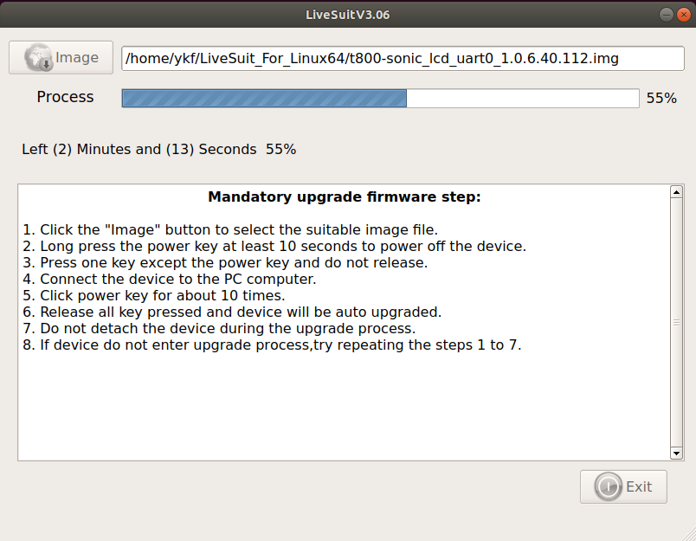

Burning is successful, the device restarts automatically

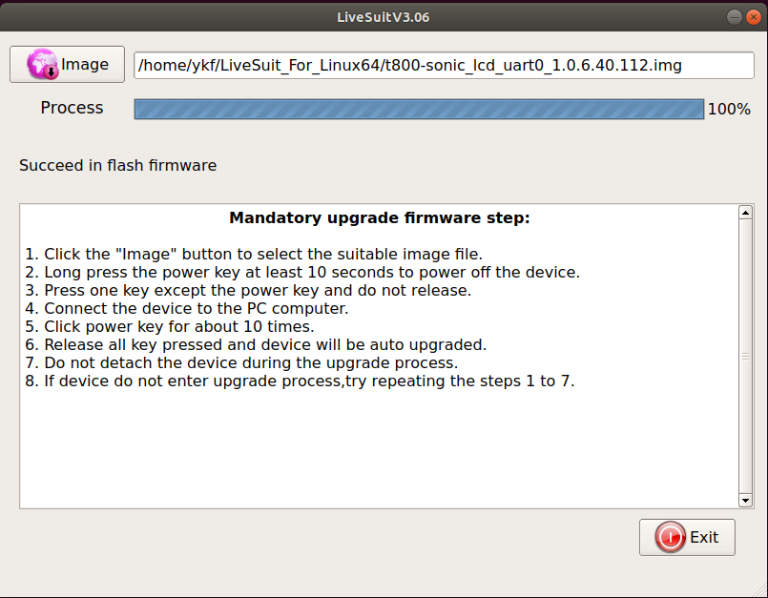

## Precautions

1. If the kernel version has been updated, the driver is not loaded automatically, please install the driver manually, the driver installation requires root privileges
2. sudo dpkg -l to check the software installation status, confirm that dkms, flex, and bison are installed, if the xxx library is missing, please execute sudo apt-get update; sudo apt-get install xxx
3. If awdev installation fails, please modify the Makefile and awusb.c files as follows

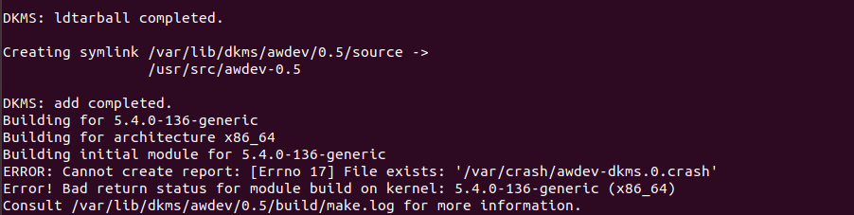

3.1 Modify the Makefile file, sudo vim /usr/src/awdev-0.5/Makefile

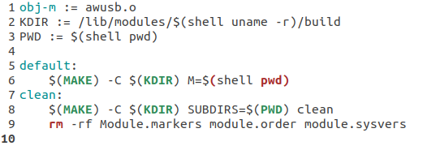

3.2 Prompt awusb/awusb.c:376:8: error: implicit declaration of function 'signal_pending' [-Werror=implicit-function-declaration]. Open the awusb.c file, add 29 to 34 lines of code, modify the content as follows:

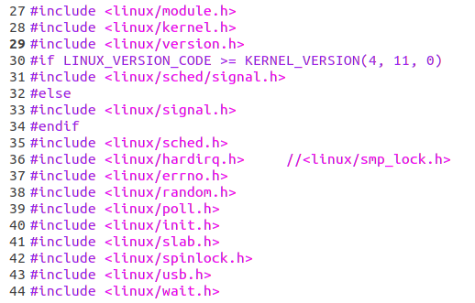

3.3 Modify the Makefile and execute sudo dkms build awdev/0.5; sudo dkms install awdev/0.5; dkms status command

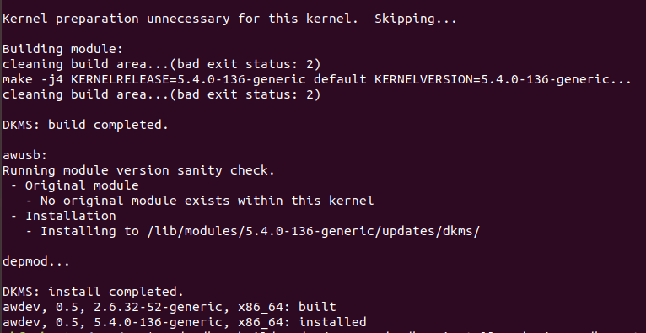

3.4 Execute sudo dkms mkdeb -m awdev -v 0.5. After successful compilation, the deb package is stored in the /var/lib/dkms/awdev/0.5/deb directory, as shown in the figure.

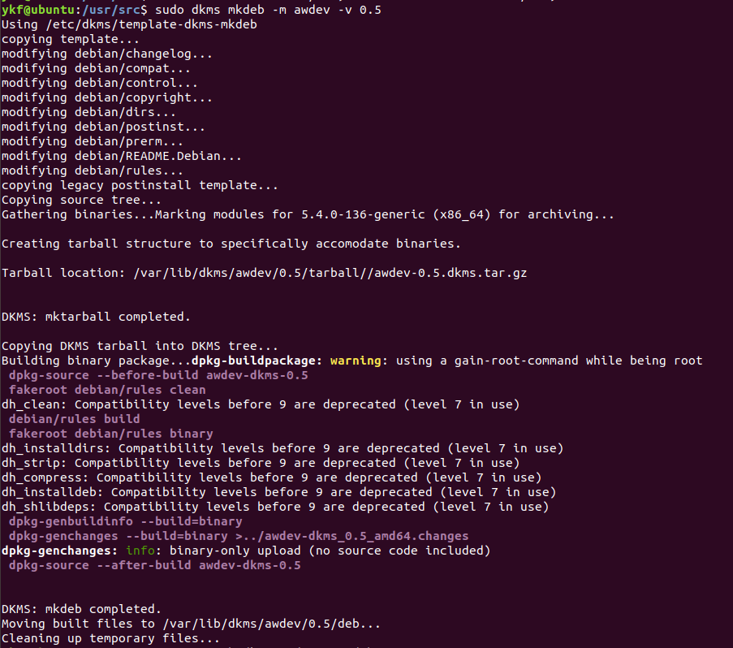

The above successfully compiled the driver deb package, and entered the sudo dpkg -i awdev-dkms_0.5_amd64.deb command to install it. After the installation is successful, execute sudo dpkg -l, you can see the awdev driver module in the module directory, as shown in the figure below

